# **Linux Assignment – Command Line Operations**

## **1. Creating and Renaming Files/Directories**

First, a new directory named test_dir was created. Then, I moved into that directory and created an empty file named example.txt. This file was then renamed to renamed_example.txt.

**Steps performed:**

* Created a directory named test_dir
* Navigated into test_dir
* Created an empty file called example.txt
* Renamed example.txt to renamed_example.txt

**Screenshot:** 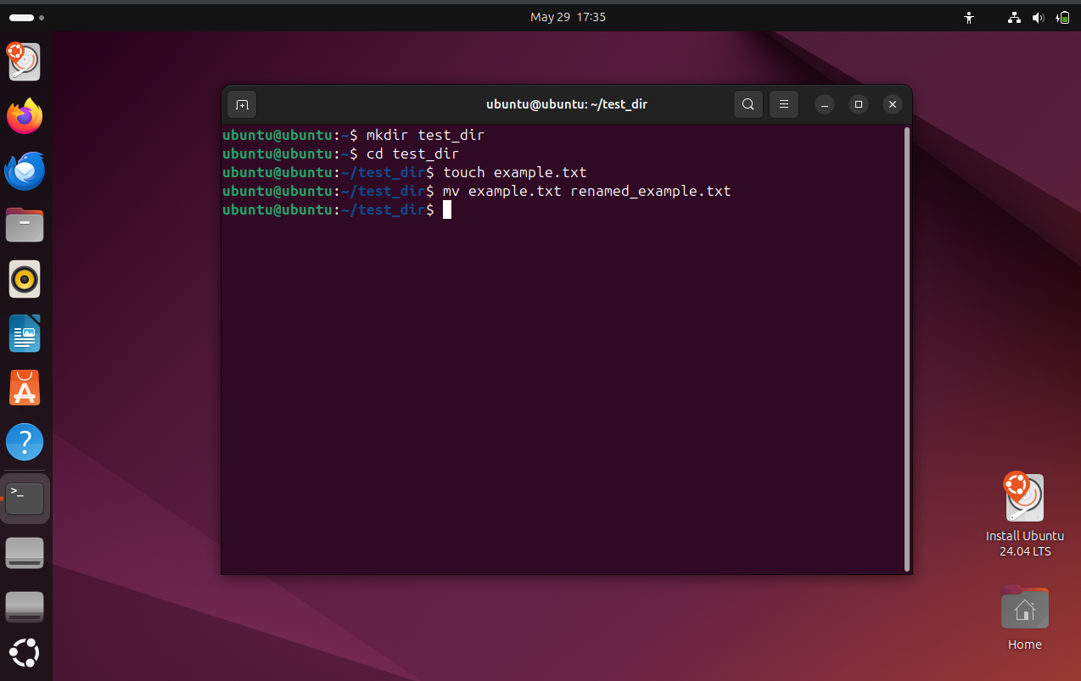

## 

## **2. Viewing File Contents**

The contents of the /etc/passwd file were viewed in three ways:

1. Displaying the full content
2. Displaying only the first 5 lines
3. Displaying only the last 5 lines

This demonstrated the ability to examine files in different ways depending on the requirement.

**Screenshot:**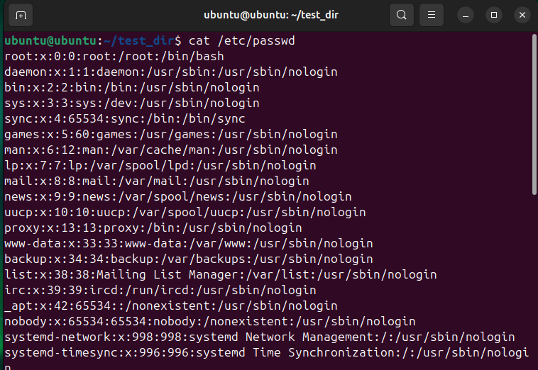

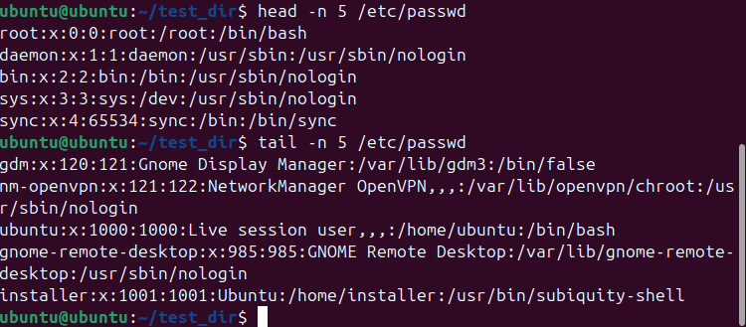

## **3. Searching for Patterns**

I searched the /etc/passwd file for any lines containing the word "root". This helped in identifying all user and system entries related to the root account.

**Screenshot:**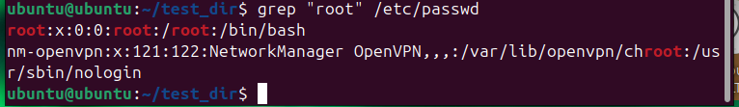

## **4. Zipping and Unzipping**

The previously created test_dir directory was compressed into a file named test_dir.zip. To extract it, a new directory called unzipped_dir was created, and the contents of the zip file were extracted into it.

**Steps performed:**

* Compressed the test_dir directory into test_dir.zip
* Created a new directory called unzipped_dir
* Extracted the contents of the zip file into unzipped_dir

**Screenshot:**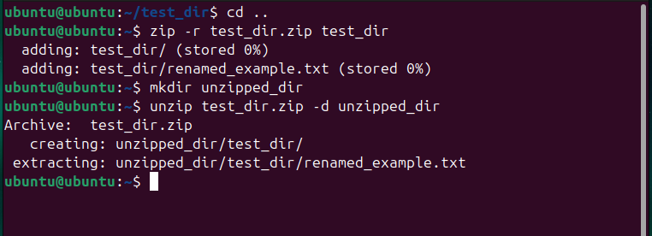

## **5. Downloading Files**

I downloaded a sample text file from the internet using a URL shortener. The file was saved as sample.txt.

**URL used to download:**https://sample-files.com/downloads/documents/txt/simple.txt

This link points to a valid and publicly available text file for demonstration.

**Screenshot:**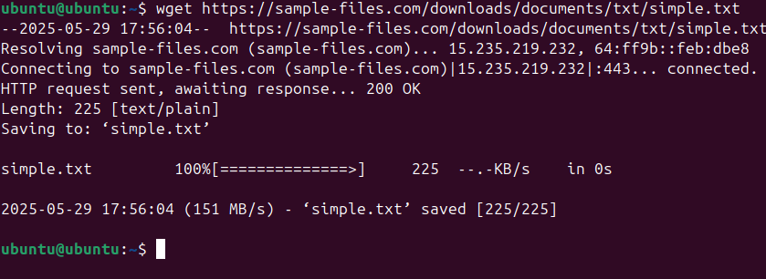

## **6. Changing Permissions**

A new file called secure.txt was created. Its permissions were modified so that it became read-only for all users. This demonstrated the use of permission control for file security.

**Steps performed:**

* Created a file named secure.txt
* Changed the permissions to make it read-only for everyone

**Screenshot:**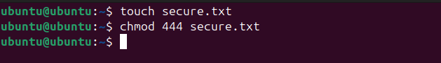

## **7. Working with Environment Variables**

An environment variable named MY_VAR was created and assigned the value "Hello, Linux!". To confirm that it was set correctly, its value was displayed.

**Steps performed:**

* Set an environment variable called MY_VAR
* Printed the value to confirm it was stored

**Screenshot:** 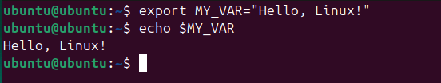

## **GitHub Repository Link**

[Insert your GitHub repository link here]